26.08.24 Introduction

mandatory assigment and 1 mandatory task before oral exam

8-12 questions on the exam, given in November
one of them would be choosen randomly on the exam, no preparation time during exam
they correlate with topics taken during classes, timetable is given

extra exercises for each topic on the course page
webpage: brightspace.au.dk

why this course?
-Hacker, everyone can do that with youtube, just coding
-Developer, got best practices but doesn’t understand what’s beneathe
-Engeeneer, got best practices and understands them, can implement and find a stolution

OOPs Object-Oriented programing

Encapsulation
Variables, Methods, Class
private lists
public setters, have to take care of vunurabilities (like minus speed)

Abstraction

Inheritance
basic (how to code it): not to repeat code; to change the whole set things

actual use: we can think of Mammal as an Animal
we can use it for the generalization

everywhere an object, that is a parent, exists, an inheritance could be used instead
ex: we used an Animal, we could also use a Mammal

homework: Inheritance – A Quiz (can send for feedback but don’t have to)
see:
bird.cs
Animal

Client
IAnimal
(Interface)

Polymorphism
Polumorph – many forms

one unit can behave in different ways
ex: units in strategy game can defend and attack

26.08.24 Extreme programming
release day by day and deliver something that customer needs
find errors and mistakes constantly (with tests) - Small releases

5 values:
communication – colleagues + customers
simplicity
feedback – from system (test often), customer, team
courage – speak the truth, seek answers
respect – team and project

abstract principles – based on the values

practices:
pair (of people) programming – proven scientifically, better quality
user stories – edge cases, strong description about what user can do
weekly cycle

rules – devided into 5 categories:
managing:
sit together, better quality and description
move people, better and wider knowledge about application
planning:
user stories – change and release faster
designing:
Clas-responsibility-collaboration (CRC) cards – create a class and write on a small peace of paper what that class does
spike solutions – later on the course
refactor – changing code without changing the behaviour
coding
talk to the team and to customers
testing
all code – you won’t remember what to test
prove bug by unit test, then fix

New XP Project
user stories 1-3 weeks
spike solutions – later on the course
release planning with whole team
begin iterative development ...
Existing project
what slows down, fix this
many bugs -> automated acceptance tests
requirement specification -> start with user stories

2_Principles_and_patterns
firstly good, then design rots and code is unreadable
redesign might be wanted
Architecture and Dependencies
Symptoms of Rotting Design
1. Rigidity
software is difficult to change, changes take more time than expected (2 days -> few weeks)
2. Fragility
similar to 1. software breakes in many places when changed unexpected
impossible to maintain, every fix makes it worse
managers lost control of their software
3. Viscosity
two forms: viscosity of the design and viscosity of the enviroment
facing change -> more than one way to make this change happen
some preserve the design, some do not (hacks)
when hacks are easier to employ than design preserving methods -> the viscosity is high
(easy to do the wrong thing, hard to do the right thing)

viscosity of enviroment
slow and inefficient enviroment => ex. Slow compliation
people will try to find another, dirty way to do this and not preserve the design

Changing requirements
requirements neet do be changed quickly, and people might not be familiar with the OG design philosophy
change works, but violates the original design
small changes accumulate

if designs are falling, because of changing requirements it is our fault

Dependency management
four symptomps above are directly/indirectly caused by wrong dependencies between modules of the software
dependency architecture is degrading -> the ability of the software to be maintaned fades
dependencies between modules must be managed by creating dependency firewalls
OOD (Object Oriented Design) – how to build firewalls

Principles sof Object Oriented Class Design

The Open Closed Principle (OCP)
most important!!
change what modules do without changing the source code of the modules
(extend without requiring them to be modified)

Dynamic Polymorphism
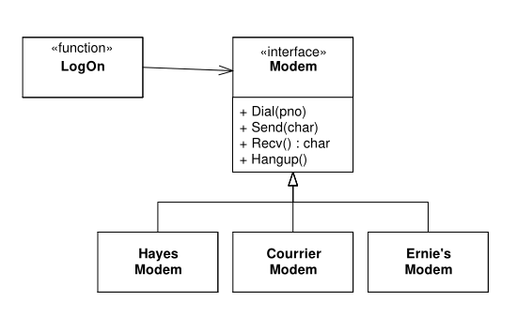

LogOn function depends only upon the Modem Interface. Other Modems will not change LogOn function. This model can be extended

Static Polymorphism
template

Architectural Goals of the OCP
create modules that can be extended without being changed
new features to the existing code

OCP cannot be fully achieved, but can improve the structure

2_SRP
SRP: The single responsibility principle
class have two responsibilities, there will be more than one reason for it to change
coupling leads to the unexpected break
ex: Rectangle class has to draw and calculate the area (two responsibilities)
more linked libraries, memory footpring, it may be forced do be rebuilt by GUI

separate those two responsibilities into different classes

Responsibility - „a reason to change”
if you think of more than one motive for changing a class, then it has two responsibilities
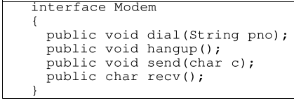
this class has two reasons to change
-communication data
-connection
they’ll change for different reasons

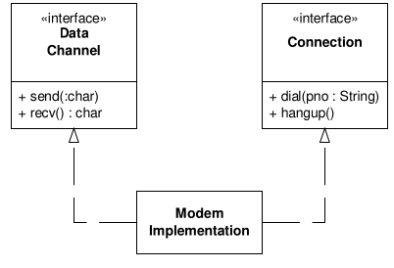

2_OCP
The Open-Closed Principle
Design modules that never change
Open for extension, closed for modification

many heuristics
Make member variables private
any other class, including subclasses, are closed against changes to those variables (encapsulation)

no global variables
never closes, everyone can change it and violate class work

RTTI is Dangerous
run time type identification
General rule: if a use of RTTI does not violate the open-closed princple it is safe

2.09.2024
Rigidity – simple changes causes a lot of changes, programmers don’t dare to make non-critical changes
Fragility – there was a problem, fixed, new problem

Immobility – a component can be reused but not easily
Viscosity – more than one way to solve a problem

Needless complexity – if you are thinking too far in the future
Needless repetitions – copy-paste

Opacity – over time code is harder to maintain and catch up with what’s going on

Single responsibility responsibility
one reason to change (method, class)
easier for testing by this approach

05.09
Open-closed principle
make changes without changing things

SOLID
S – Single responsible principle
O – Open-closed principle

07.09 3_lsp
Liskov substitution principle

The principle says, that function which uses pointers/ref. to the base class must be able to use objects of derived classes without knowing it.

Basically it violates OCP, function/class which uses reference must know about all derivatives of the base class to use them.
It must be modified whenever a new derivative (of the base class) is created

The client expects that all derivatives must conform to the behaviour of the base class
, so he doesn’t need to check the type (this would violate the OCP)

07.09 3_dip
Dependency Inversion Principle

The cause of Bad designing
1. rigidity – single change → cascade changes.
Cost and size of change is unpredictable? Officialy rigid
2. fragility – single change → many problems
can’t predict the quality of product, simple changes → failures in other parts → fixing? → more problems
3. immobility – desirable parts of the design are dependent upon not desired details
not possible to reuse the design

Dependency inversion
no inversion:
module containing the high level policy is dependent upon the low level detailed modules.
Thus it’s not reusable
inversion:
dependencies are inverted if higher and lower level modules depend upon an abstraction

Dependency inversion principle
1. High level modules should not depend upon low level modules, both should depend upon abstractions
2. Abstractions should not depend upon details. Details should depend upon abstractions.

Layering
All well structured OO acrchitectures have clearly-defined layers
naive layers are:
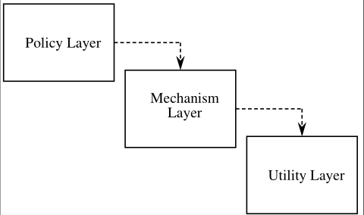
You can clearly see, that Policy layer uses Mechanism layer,
so it is sensitive to all changes, further, it is sensitive all the
way to the Utility layer changes

better layers:
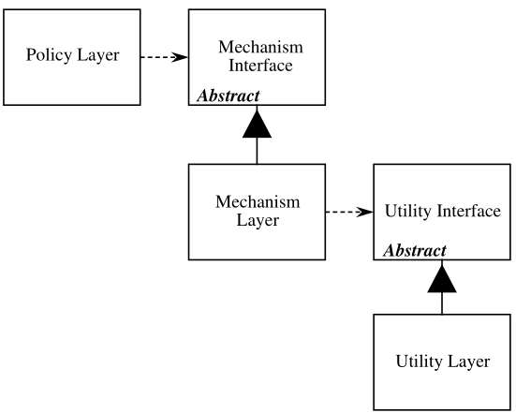
This approach is better, each lower layer are
represented by an abstract class. Higher level classes uses
lower level classes through an abstract interface

Conclusion
Modules that encapsulate high level policy should not depend upon modules that implement details.
Rather, both kind of modules should depend upon abstraction
07.09 3_isp
Interface Segregation Principle

the interface of the class can be broken up into groups of member (virtual) functions. Each group serves a different set of clients.
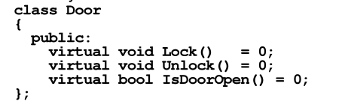
= 0 means for functions means that class is abstract.
Clients that use object that conform to the Door
interface don’t have to depend upon implementation

Interface pollution
one interface is forced to know about other interface which it doesn’t require

12.08
lsp

“Routine declaration of a derivative may only replace original precondition with one equal or weaker and the original postcondition with one equal or stronger”

when you are doing subclass thin: IS-SUBSTIUATABLE-FOR instead of IS-A

CUPID
Composable
Unix philosophy ls -a | grep – not intended, but can be combined
Predictable
Idiomatic
Domain-Based

once again
SOLID
S: SRP – each class/module single responsibility
O: OCP – extendable without modification
L: LSP – any client of a class should be able to use subclasses without problem
I : ISP – user not depended on methods which doesn’t use
D: DIP – high-level not depended on low-level. Details should depend on abstraction

16.09
the architecture is a compromise between user, business, system

Structure
one project can call data from other but cannot see their interfaces

Architecture
“Everything should be made as simple as possible, but not simpler”

an architecture is a aset of models, and model has 3 characteristics:
-must be based on a system
-must reflect a relevant subset of the system’s properties (as simple as possible…)
-can be used to think about the system in a limited cotext (...but nt simpler)

RUP – Rational Unified Process
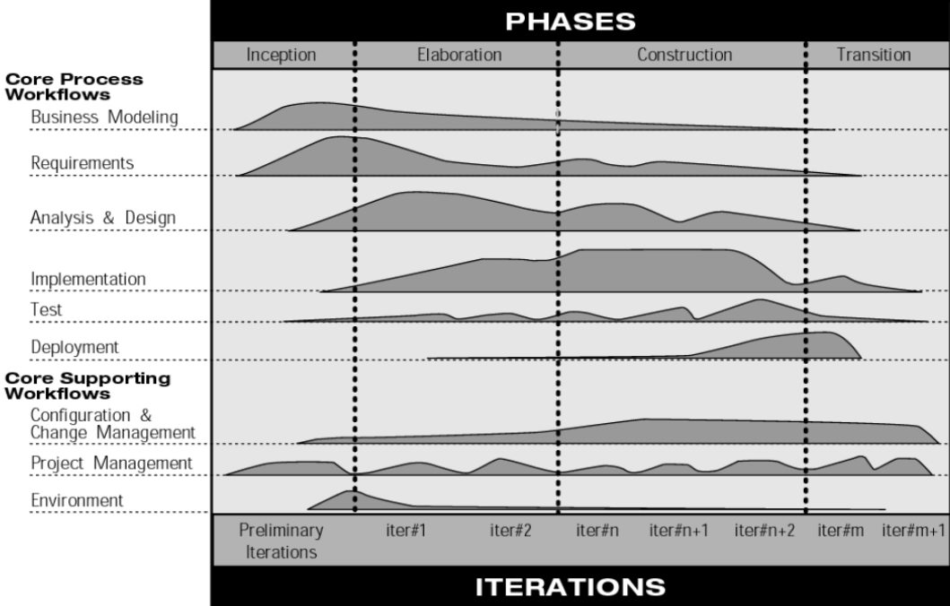

Key Scenarios
exam
ex.: “All Danish students should be able to upload a .pdf file for their exam every half a year between 12-13”

think of:
critical functionality (and requirements),
critical non-functional requirements,
exploration (unknown areas) – videos for milions of people at the same time
risk mitigation -

look for functional requirements from intersected sectors of user, business and system’s

19.09
An architecture process from Microsoft

1. Identify architecture objectives
input, output, who will use them, what are you creating

2. Key scenarios
something

3. Create an application overview
identify important architectural design styles

4. Identify key issues
problems that must be solved with (the version of the) architecture

5. Define candidate solutions
key solutions to key issues

Architecture styles
Layers (style)
user←→ presentation → business → data ←→ database / services

we stack each layer on top of each other
dependencies always go lower in the structure, we can reuse the structure
data source and user can go up and down

layer is a logical separation, tier is a physical separation

other examples: MVC MVVM, ISO OSI (network)

benefits:
separation high-level to low-level
reuisng, coupling (zależność), cohesion (spójność), clarity
concurrent development in the team is reduced because of semgmentation in logic
layer can be replaced
testing easier

Client/Server
Server is on the different machine, connected to users (1←→n) by network
Server is responsible for handling requests, responding, and keeping data

N-tier Architectural style
client server, which presentation, business and database are separated physically (tiers)
presentation tier ←→ business tier ←→ database tier

benefits:
scalability – you can copy your server/database machines and distribute the flow
reusability – tiers can be reused on a different devices with different software
data integrity – bussiness tier can guarantee that only valid data is passed to the DB
improved security* – client doesn’t have direct connection to DB
reduced distribution – changes to business logic need to be updated on business only
improved availability – can create redundant servers/DB to secure the data from crash

disadvantages:
increased complexity/effort – more complex to build compared to 2-tier architecture,
communication tiers have to be developed,
server crashes, communication slowed/failed,
security* at every tier, also in the communication

Pipes and filters
for streams of data, data keeps flowing into system and it has to handle it
each step (filter) is doing a specific thing
data is passed through pipes between filters
if something works in sequential (in stages), it ensures (for ex.) correct input types for next step
pipelined – can work on threads and speed up this process

Message bus
applications can interact without knowing who has sent a message (with using communication channels)
applications can communicate without knowing each other

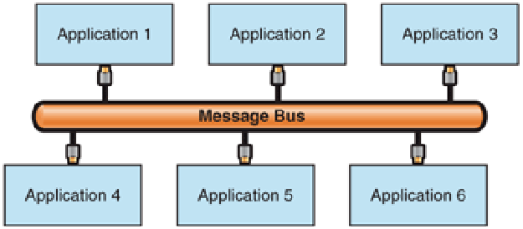
→ scallable, extendable

23.09
Software architecture documentation

all about communication, deliever needed knowledge, just enough to introduce poeople to your application without forcing them to look at the code

use right abstraction model
C4 Model by Simon Brown - 4 levels
context → containers → components → code

made up of one or more container(s),
each of which: one or more component(s)
each of which: one or more: code element(s)

Level 1 Context diagram
big picture, show to non-technical people (miss technical details)
who is a user?

Level 2 Container diagram
a container is a separately runnable/deployable unit (process, exe, db)
high-level shape of architecture and how responsibilities are distributed
shows the major technology and how containers communicate with each other

Level 3 Component diagram
which component is responsible for what, what technologiesm implementation details
major structural building blocks for container

typically they execute in the same process space

Level 4 Code (optional)
zoom to each component to see how it’s implemented
using UML class diagrams
include on those diagrams only this attributes/methods that allow you to tell the story (unreadable diagram)

Diagram guidelines
self-explanatory
explain on the diagram what everything means
!!! add text !!! – helpful for further expanding
use colors, shapes – readability
diagram should be read by narrator, not be explained

! ! C4 is only about structure. Behaviour is also important ! !

26.09
https://www.uml-diagrams.org/

The 4+1 view model
Key scenarios connected with all four:

Local view end user
Process view how we scale
Development view how the software is structured, where to put components
Physical View System engineering, where system deployed, how the system talk together

package diagrams – big project
component diagrams – small projects, too much details
deployment diagrams -
sequence diagrams – method calls
communication diagrams – single use case
state machine diagrams
activity diagrams – how data / which data is flowing and who’s processing

30.09

exam → show design pattern and match SOLID principle
gang of four design patterns (ex. Which category ‘factory method’ belongs to)
remember which pattern you write in hand-in

SOLID applies

Gang-Of-Four
pattern description template

antiy-patterns – do not use xd, created by someone somewhen and aren’t used

static - you can call instance without calling the constructor

GoF – Observator
observes changes (ex. Data) and reacts to a change
one-to-many relation – when object changes state all its dependencies should be notified automatically

week 6 pres. 2
page 6
abstract class – can have an implementation of a method. You can only inherit from 1 class/abstract class
interface – cannot have an implementation, just tells that method should be implemented.
Many can be inherited

observer should be an interface. Many ConcreteObservers will work differentelly, but they have to implement +Update()
make sure that Subject can be as detached from Observer as strong possible

* - (on the arrows) many-to-many relationship – observer can listen to many subjects

warning!
Upper – one-to-many
here - many-to-many
page 7
Notify( ) loop:
SetData( ) calls Notify( ) which allows Update( ) to be called

07.10 (week 7.1)

Template method pattern
extendible
!!! uses inheritance !!!

Strategy pattern
extendible
!!! uses delegation !!!

whatever the strategy is, just do it
if strategy changes, and we call handle(), we can behave in very different way

single responsibility – we have 1 ConcreteStrategy, which we handle

eliminates switch/case

10.10
factory pattern and abstract factory
exam (factories)

seperate creation and use of an object (SRP)
creation – open for extension, closed to modification (OCP)

Factory method
let the classes implement the interface and DECIDE which objects to iniciate

difference from template method
groups:
template – behavioural
factory – creational
factory is more forgiving

ex:
you got class “civilization”
we don’t know exactly how
german part of this would implement what they want
french might implement other things

21.10
State machines
finite number of defined states
can transition between states (phone → from silent to vibrate … to loud)

there can be some trigger-signatures (low battery → low light)
you can make some state diagrams
ex: doors must be first closed to be locked. Doors must be first locked to get unlocked

how to implement?
Switch-case / tables / GoF state pattern

Switch-case implementation
good for simple designs – ex. One button that changes states, no matter what change was before

SRP – open for extenstion, not closed for modification
OCP – not really, (flashlight example) you have to watch for events, get input and change state

Table-based implementation
you can represent a state machine as a table of transitions

complexity – grows fast
understandibility – depends on complexity

GoF state pattern
complexity – still big
better for testing?

Implementation
Context – class that contains current state and methods for changing states
each method (eventAOccured) contains of an action method and a handling method
SRP – yes
OCP – yes but not really 100% - change of events? Need to modificate

switch-cases are still there, they are just moved

context is not responsible for setting a new state

henrik – introduction to an assigment
each group must choose a pattern (that we haven’t discussed in class yet)
assigment would be a good use of an pattern on the exam (you might get that topic)

list of patterns on coursepage – (A) means bigger projects
positive list: approved (checked) if there is enough material to cover during exam
negative list: you may struggle, because there is less material for those topics
BE QUICK!!!
there are limited amount of groups that can take the same topic

requirements: (read on coursepage)
make both report and the presentation and demonstration video
why? You get the feedback before an exam (6 min video)

you have to make a review for 2 other groups

special lecture to help us with the assigment (no extra material there)
24.10
nested and orthogonal (state)

28.10
refactoring - making changes
imporve code quality

do after: when works, when passes tests
DO NOT change visible behavioural

Code smells – something is off about the code

Assignment Decorator pattern
multiple additions (soya milk, steamed milk) means a lot of subclasses
violates two priciples, which?

→ add booleans like “hasSteamedMilk” but now you need get/set for each of them
What requirements or other factors might change that will impact this design?

Decorating object’s type mirrors the type that it is decorating (the same type)
those object inherits all the methods
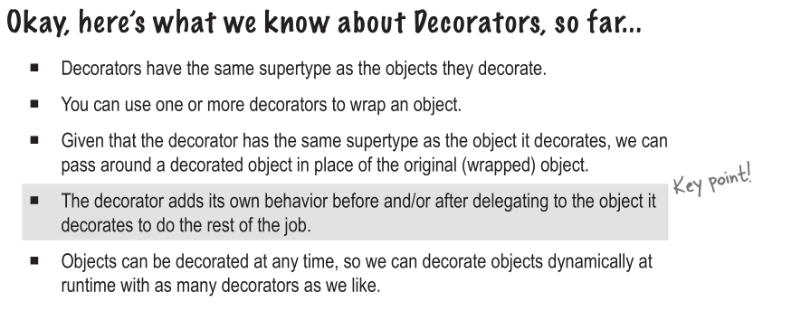
The decorator pattern attaches additional responsibilities
it doesn’t give us a lot of insight how to apply the pattern in our implementation
structure on the page 91

Decorator has a reference to instance that it decorates

page 93 – confussion between inheritance and composition
using: type matching
not using: behaviour

11.11

a task is not a thread
sequential operation
TPL – task parallel library

two methods – DoLeft(), DoRight()
make them parallel in DoAll()
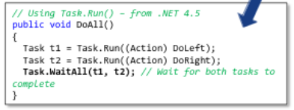
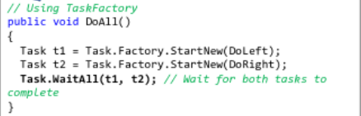
Tasks are placed in a work queue and not executed on a creation

The default task scheduler

for(int i=0; i< 10; i++)
Task.Run(()=> {
Console.WriteLine(“ Hello from task " + i);
});

//10 10 10 10 10
scheduleding takes long, and execution is run too late

declare
var localI = i
in each iteration
!! works only for simple types, not objects

for objects, declare a method
public void Run()
inside the class

make sure that program works, even if it is waiting for something (like user input)
public async void ...
await – we wait for the completion of an asynchronous operation
“you asked me something an hour ago, there is a result”

14.11

static or dynamic partitioning
- static: requires a knowledge of execution time, requires no synchronization
- dynamic: requires synchronization but no timeta

18.11

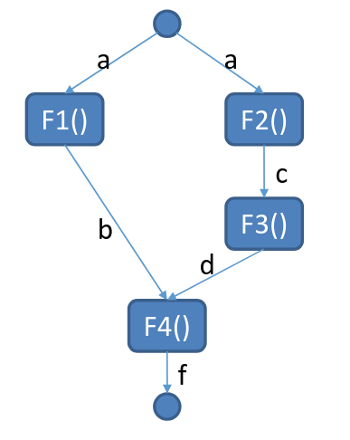
future values

var a = "A";
Task<string> futureB = Task.Run(() => F1(a));
var c = F2(a);
var d = F3(c);
var f = F4(futureB.Result, d);
Console.WriteLine(f);

F1 finished → result immediately returned
F1 running → until future result is avaliable

